
Hotel Management System
Final Project Report

Presented By:
Muhammad Saad (Authentication and room management)
Agha Meharullah Khan (Room booking and Booking cancelation)
Abdullah Tanveer (Booking receipt Password update)
Yasir Ali (Customer Ui and Booking list)
Submitting to: Miss Sarah Khan

1. Project Overview
The Hotel Reservation System is a Java-based desktop application designed to streamline room management and guest bookings. It utilizes a Three-Tier Architecture (Presentation, Business Logic, and Data Persistence) to ensure a modular and scalable codebase.

2. Theoretical Framework (The 4 Pillars of OOP)
The system is built on the core pillars of Object-Oriented Programming to ensure code maintainability:
Abstraction: Used via the abstract class Room. It hides the complexity of price calculations from the UI, exposing only the necessary calculatePrice(int days) method.
Encapsulation: Sensitive data such as roomNumber, pricePerNight, and user credentials are kept private. Access is controlled through public getters and setters to maintain data integrity.
Inheritance: Specific room categories (Deluxe, Standard) inherit common traits from the base Room class, reducing code duplication and allowing for shared behavior.
Polymorphism: The system handles various room types through a single Room reference. At runtime, the JVM executes the specific logic for the subclass (e.g., Deluxe vs. Standard).

3. User Roles & Key Features
The system supports three distinct user roles, each with a specialized dashboard and set of permissions:
- Admin (Super User)
System Analytics: View a graphical breakdown of the user demographic (Sub-Admins vs. Customers) using a PieChart.
Revenue Management: Track total revenue generated from all confirmed bookings.
Inventory Overview: Monitor total rooms, available rooms, and active bookings across the entire hotel.
B. Sub-Admin (Staff)
Operational Control: Manage room availability and update room statuses.
Booking Management: Access the BookingService to verify or cancel guest reservations.
C. Customer (Guest)
Dynamic Room Discovery: View real-time available rooms with a modern UI.
Automated Booking Form: A multi-step form that includes:
Numeric Validation: The phone field is restricted to digits only (rejects alphabets) to prevent data entry errors.
Date Logic: Prevents booking past dates and ensures Check-Out is after Check-In.
Live Price Calculation: Calculates the total cost instantly based on nights stayed and extra services (WiFi, Dining, Laundry).

4. Key Technical Components & Interfaces
Interfaces (FormUi, Dashboard)
Standardization: Interfaces define a strict contract for all UI classes, ensuring every form has a validate() and getLayout() method.
Loose Coupling: Allows the Layout manager to switch between different views (Dashboard vs. Booking Form) without knowing their internal logic.
Data Persistence (File Handling)
Flat-File Storage: The system uses .txt files (e.g., rooms.txt, bookings.txt) for permanent data storage, eliminating the need for complex database setups while ensuring data persists after the app closes.
Receipt Generation: Upon every successful booking, the system generates a professional text-based receipt with a unique transaction ID.

5. Development Steps (SDLC)
Requirement Analysis: Researching hotel workflows and identifying user needs (e.g., numeric-only phone fields).
Architecture Design: Defining the abstract Room class and the relationship between users and bookings.
UI/UX Development: Building the JavaFX layouts, ensuring scannability with ScrollPane and professional spacing.
Integration & Testing: Connecting the BookingService with the BookingForm to ensure calculations and file saving work seamlessly.

Class Diagram:
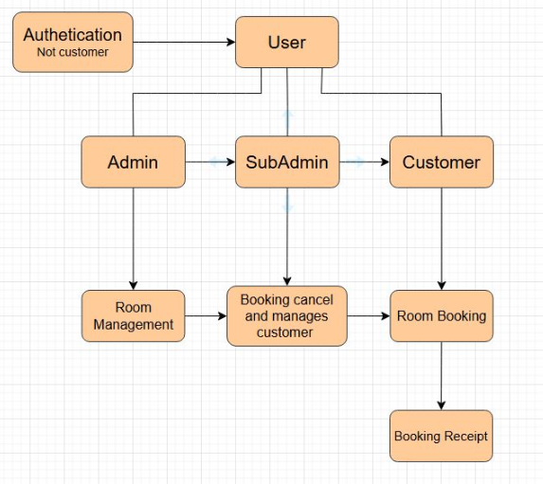

CODES: Registration
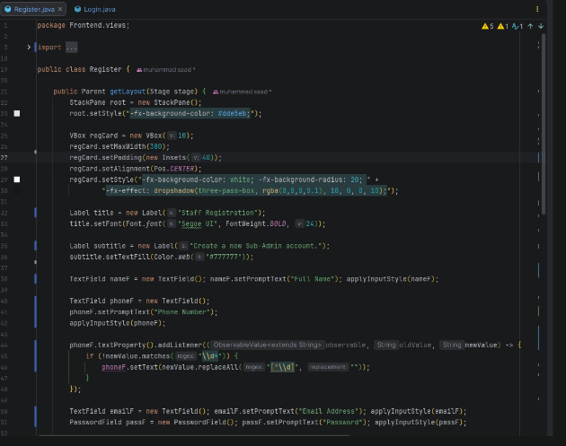

User Login:
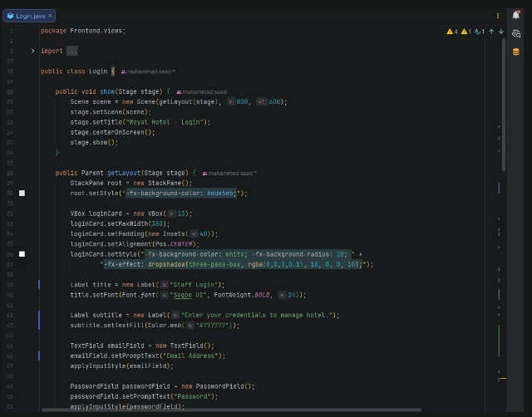

User:
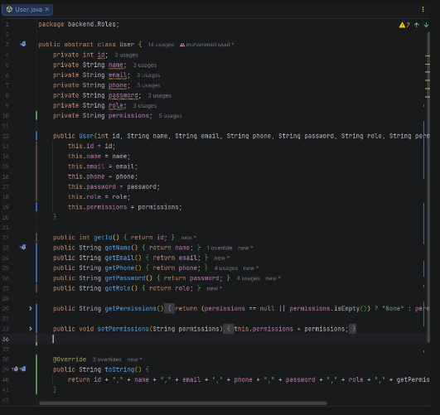

Admin:
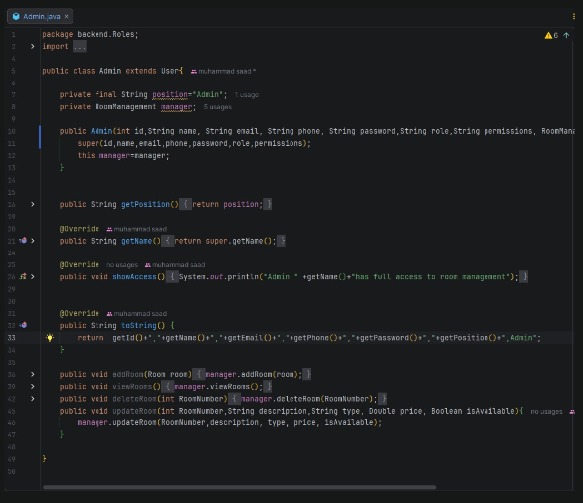

Customer:
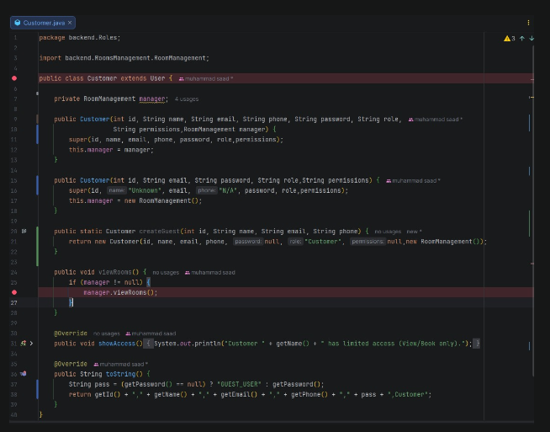

SubAdmin:
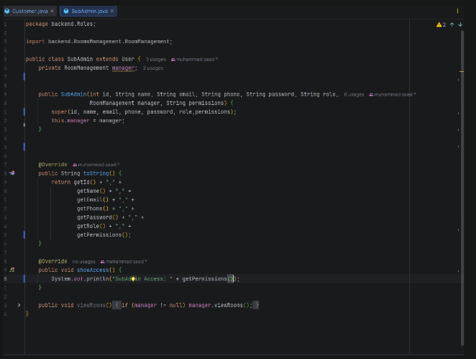

Room:
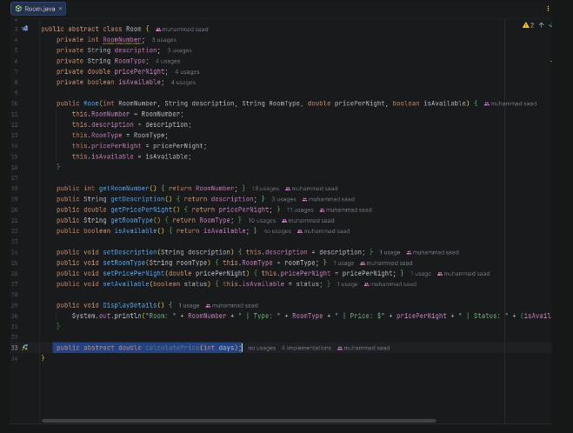

Single Room:
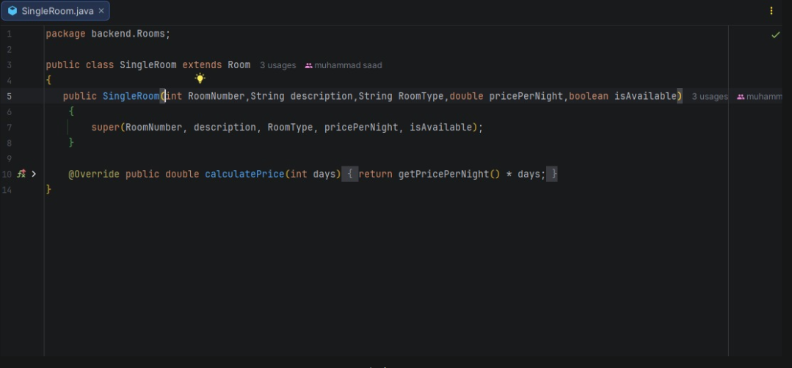
Suite Room:
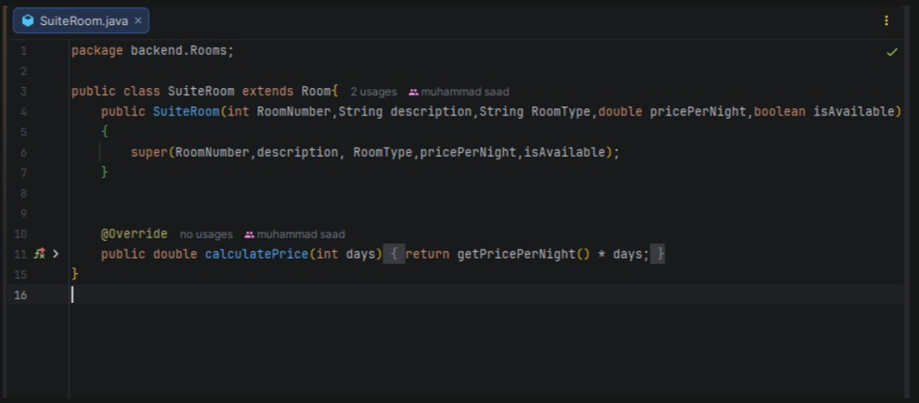

Double Room:
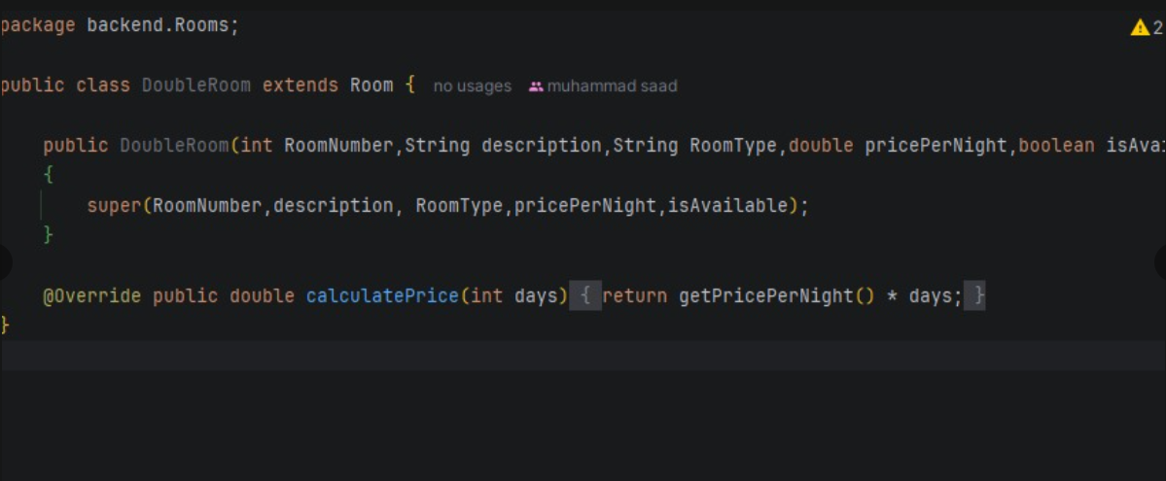
Deluxe Room:
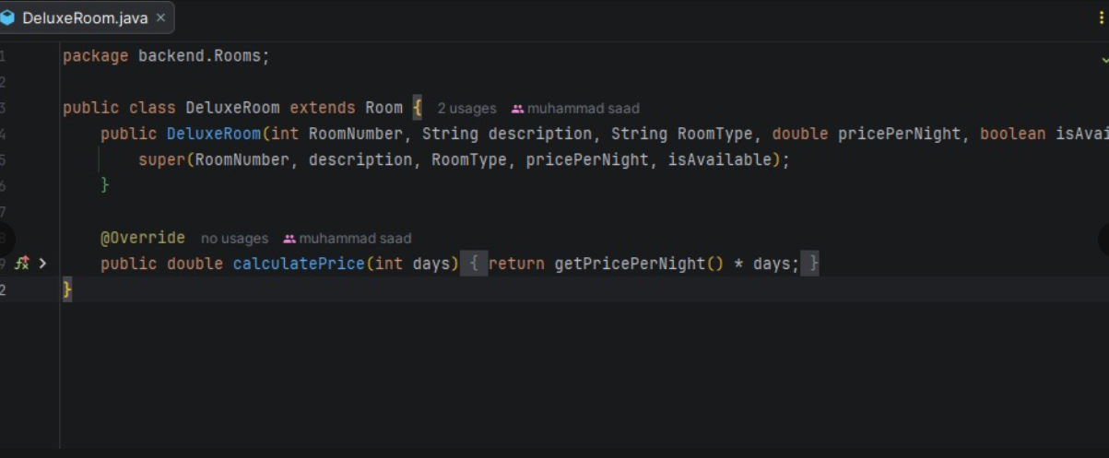

Room Management: Booking
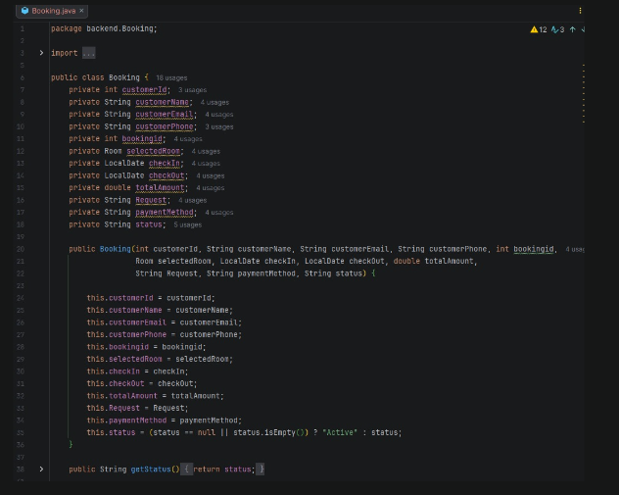

GUI:
Login:
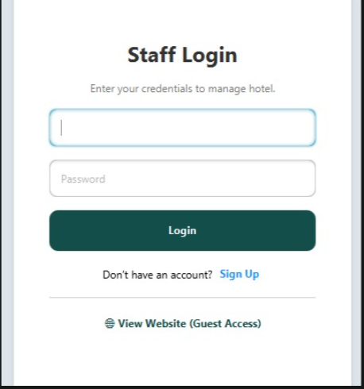

Register:
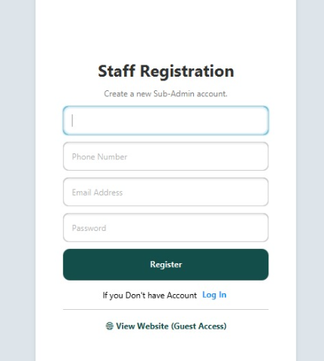

SubAdmin List:
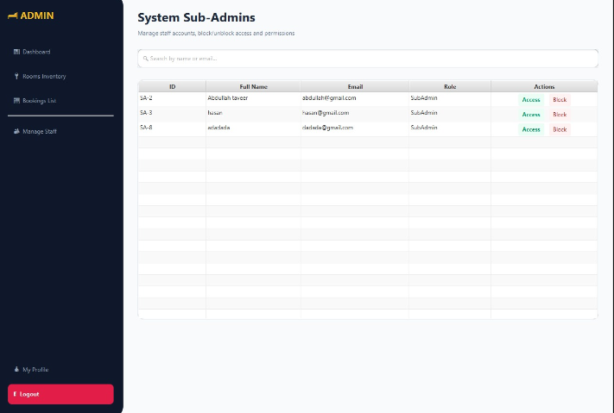

Dashboard:
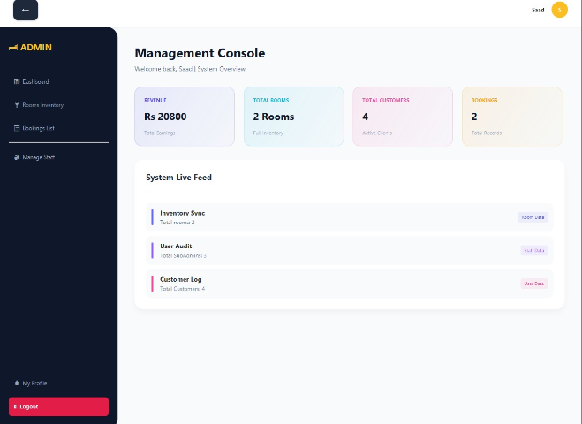

Room form:
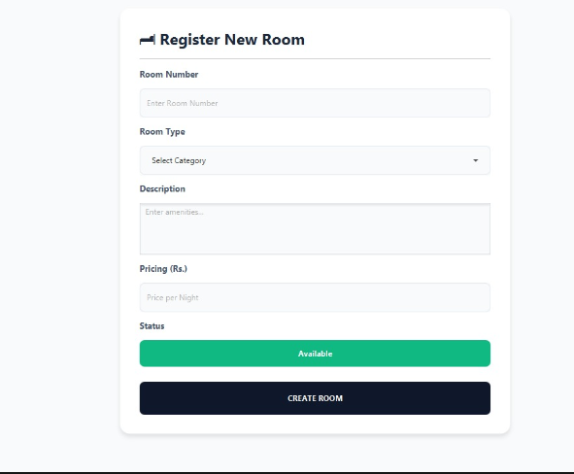

ManageAccess form:
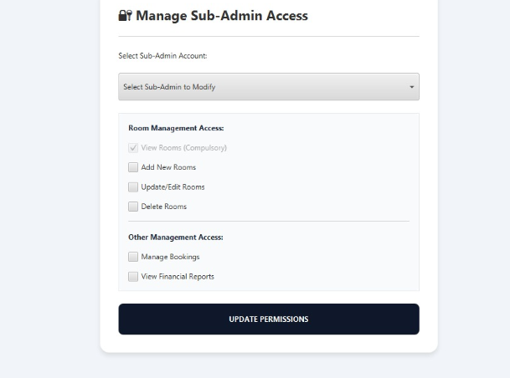

Profile:
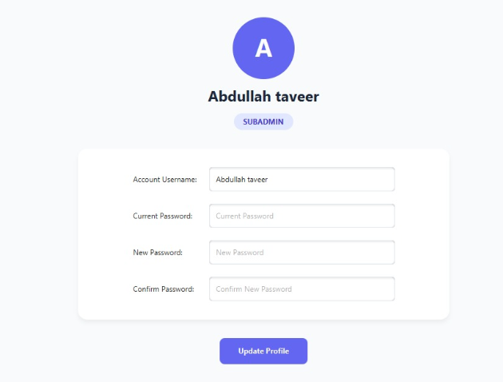

Booking List:
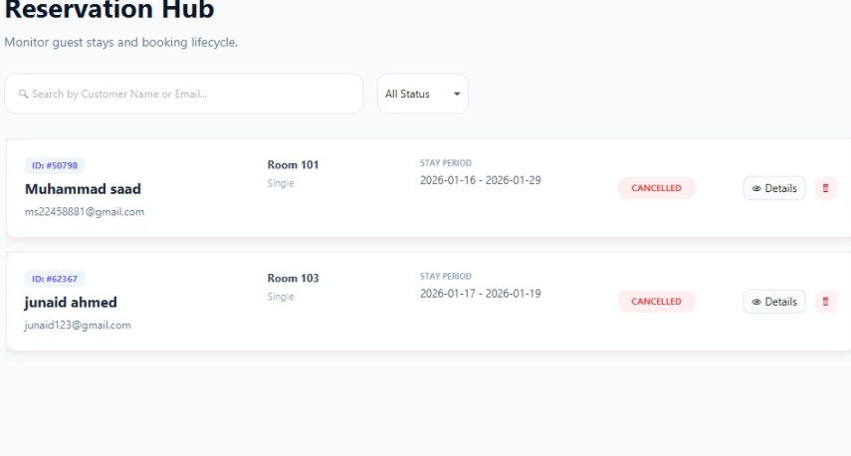
Customer Landing page:
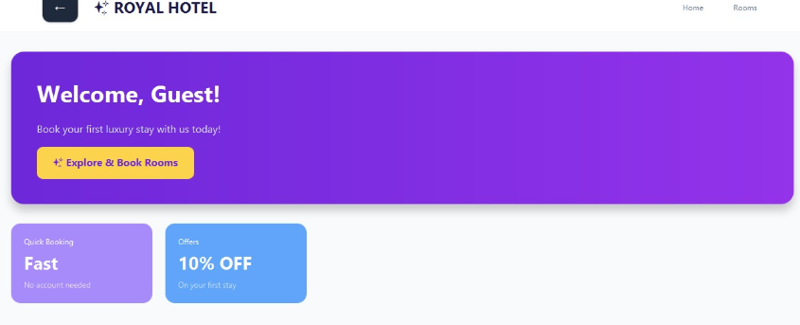

CustomerRoom List:
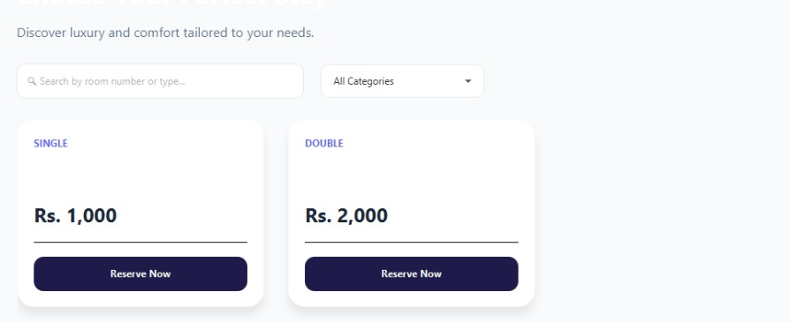
BookingForm:
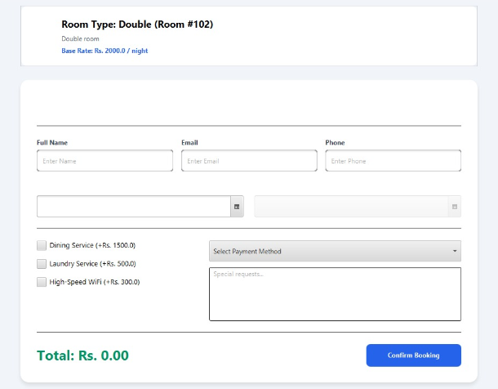

Conclusion:
The project concludes as a Modern Hotel Management Ecosystem that successfully integrates professional UI/UX standards with robust backend security.

Core Strengths
Operational Intelligence: By replacing static tables with Dynamic Dashboards, the system provides real-time business insights. Admins get high-level financial overviews, while Sub-Admins get actionable operational tasks.
Role-Based Security: The implementation of strict Access Control ensures data integrity, allowing staff to manage bookings while restricting sensitive administrative actions to authorized users only.
Efficiency & Search: Features like Instant Filtering and Real-time Search transform the software from a simple database into a high-speed management tool capable of handling large volumes of guest data.
Professional UI: The use of Card-based Layouts and Visual Indicators (like status badges and progress bars) provides a premium software experience that rivals modern commercial ERP solutions.

End.

